**FSD Laboratory 02**

**Name:Janhavi Pawar**

**Roll no:-01**

**Panel:H**

**PRN:1032231531**

Aim: Design and develop a responsive web page using Bootstrap front end framework.

Objectives:

1. To understand HTML tags

2. To learn the styling of web pages using CSS

3. To learn Bootstrap Front End Framework.

Theory:

1. Bootstrap Grid System.

Ans:-

The Bootstrap Grid System is a flexible and powerful layout framework designed to help developers create responsive, structured web layouts. It leverages a 12-column grid to organize and align content. Here's a brief overview of its key concepts:

### 1. **Grid Structure**

1. **12-Column Layout:**

* The grid is based on 12 columns. By combining and adjusting these columns, you can create various layouts and align content across different screen sizes.

2. **Containers:**

* **.container**: A fixed-width container that adjusts based on the viewport size.
* **.container-fluid**: A full-width container that spans the entire width of the viewport.

3. **Rows and Columns:**

* **Rows**: **.row** is used to create horizontal groups of columns.
* **Columns**: **.col-** defines a column and can be sized using classes like .col-, .col-sm-, .col-md-, .col-lg-, and .col-xl- to control the width at different breakpoints.

### 2. **Responsive Breakpoints**

Bootstrap’s grid system adapts to various screen sizes through breakpoints:

* **Extra Small (xs)**: <576px
* **Small (sm)**: ≥576px
* **Medium (md)**: ≥768px
* **Large (lg)**: ≥992px
* **Extra Large (xl)**: ≥1200px

Different column classes are used to define how many columns an element should span at each breakpoint.

### 3. **Column Sizing**

1. **Automatic Width:**

* **.col**: Columns will automatically adjust their width based on available space, equally distributing the space.

2. **Fixed Width:**

* **.col-{breakpoint}-{number}**: Defines the number of columns an element should span (e.g., .col-md-4 for a 4-column-wide element on medium screens).

### 4. **Offsets, Ordering, and Alignment**

1. **Offsets:**

* **.offset-{breakpoint}-{number}**: Creates space before a column (e.g., .offset-md-2).

2. **Ordering:**

* **.order-{breakpoint}-{number}**: Changes the order of columns within the same row (e.g., .order-md-2).

3. **Alignment:**

* **.align-self-{alignment}**: Aligns individual columns within the row (e.g., .align-self-center).

### 5. **Nesting**

Columns can be nested within each other to create complex layouts. Use **.row** and **.col-** classes within a column to nest further columns.

### 6. **Grid Flexibility**

The grid system uses Flexbox for alignment and spacing. This provides flexibility in positioning and aligning columns.

1. Bootstrap .container and .container-fluid class.

Ans:

1. **.container Class**

* **Purpose:** Creates a fixed-width container that adjusts its size based on the viewport size.
* **Width Behavior:**
  + **Extra Small (xs):** 100% width with fixed max-width.
  + **Small (sm):** Max-width of 540px.
  + **Medium (md):** Max-width of 720px.
  + **Large (lg):** Max-width of 960px.
  + **Extra Large (xl):** Max-width of 1140px.
  + **Extra Extra Large (xxl):** Max-width of 1320px.
* **Usage:** Ideal for fixed-width layouts where you want consistent margins on both sides.

2. **.container-fluid Class**

* **Purpose:** Creates a full-width container that spans the entire width of the viewport.
* **Width Behavior:**
  + **Always 100%** width of the viewport, regardless of screen size.
* **Usage:** Ideal for layouts where you need content to stretch from edge to edge, such as full-width images or sections

FAQ:

1. What is a responsive website?

Ans:

A responsive website is designed to provide an optimal viewing experience across a wide range of devices, from desktop computers to mobile phones.

It automatically adjusts its layout, images, and content to fit the screen size and orientation of the device being used, ensuring usability and readability without the need for horizontal scrolling or excessive resizing.

Key aspects of responsive design include:

* **Fluid Grids**: Layouts that use percentage-based widths to adapt to different screen sizes.
* **Flexible Images**: Images that scale according to the screen size to avoid overflow.
* **Media Queries**: CSS rules that apply styles based on device characteristics like width, height, and orientation.

This approach enhances user experience by ensuring that content is accessible and visually appealing on any device.

1. How Bootstrap helps to design a responsive website?

Ans:

**1. Responsive Grid System**

* **Grid Classes**: Bootstrap uses a 12-column grid system that adapts to different screen sizes. By applying grid classes (.col-md-, .col-lg-, etc.), you can control how content is laid out across various devices.
* **Containers**: Use .container for fixed-width layouts and .container-fluid for full-width layouts, ensuring content adapts to different screen sizes.

**2. Media Queries**

* Bootstrap includes predefined CSS media queries that apply responsive styles at different breakpoints. This allows for fluid adjustments of layout, font sizes, and other design elements.

**3. Responsive Utilities**

* **Classes for Visibility**: Classes like .d-none, .d-sm-block, and .d-md-none control the visibility of elements based on screen size, allowing you to show or hide content as needed.
* **Visibility Helpers**: These helpers make it easy to customize what users see on different devices without writing custom CSS.

**4. Fluid Layouts**

* **Flexible Images**: Bootstrap provides classes like .img-fluid that ensure images scale correctly within their containers, maintaining responsiveness without manual adjustments.

**5. Predefined Components**

* **Responsive Components**: Bootstrap’s components (e.g., navbars, modals, carousels) are designed to be responsive out of the box. They adapt to various screen sizes and orientations.

**6. Responsive Typography**

* **Responsive Font Sizes**: Bootstrap includes utilities for adjusting font sizes based on screen size, ensuring text remains legible on all devices.

Output: Screenshots of the output to be attached.

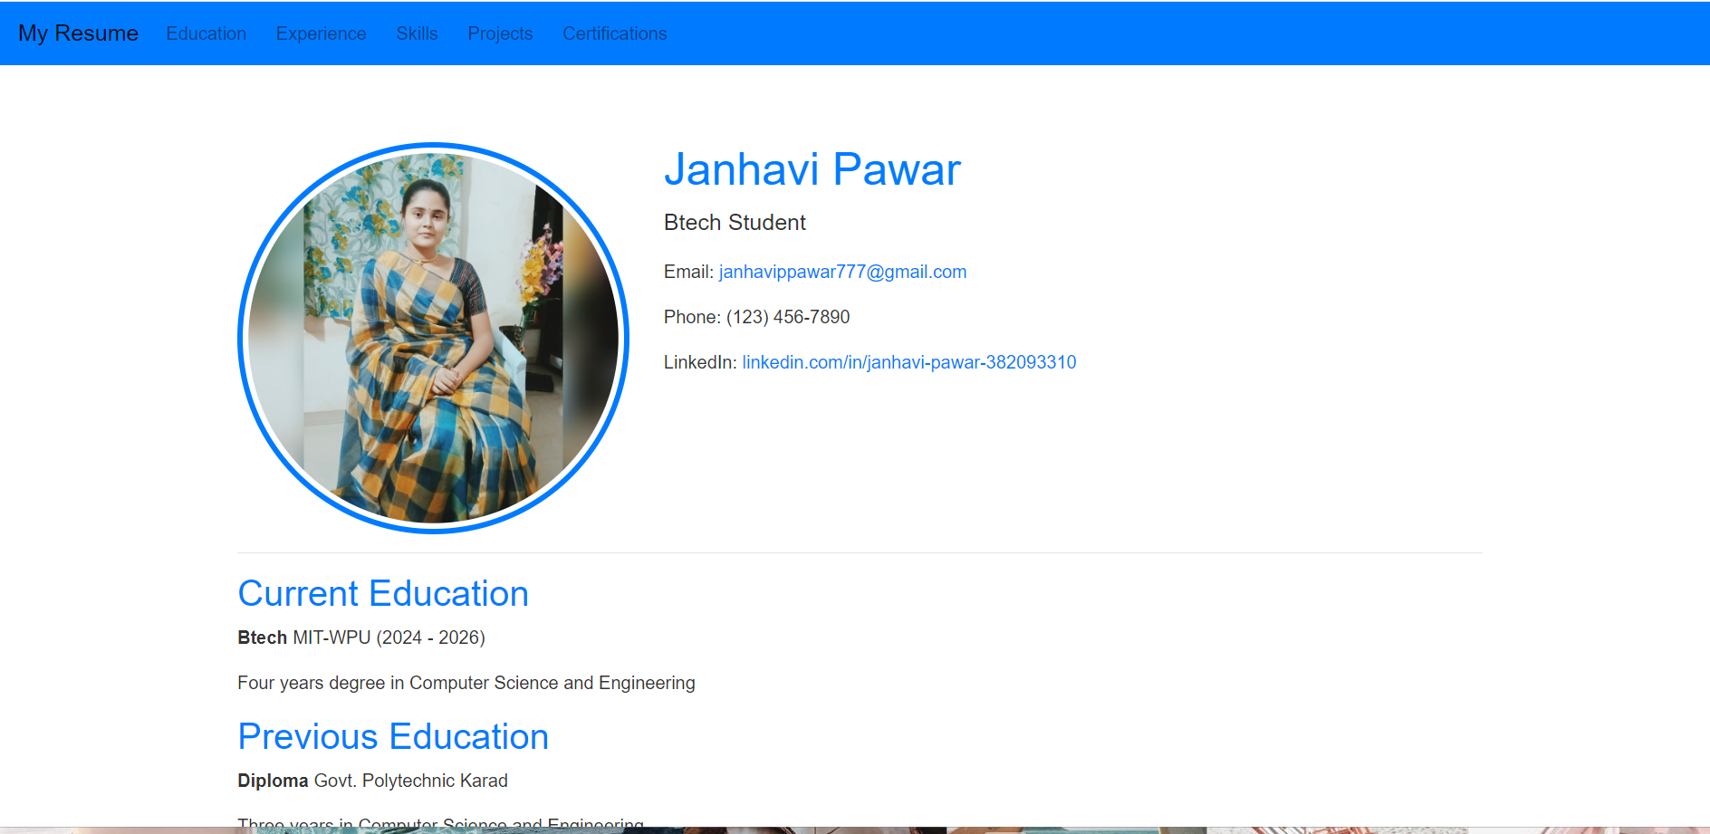

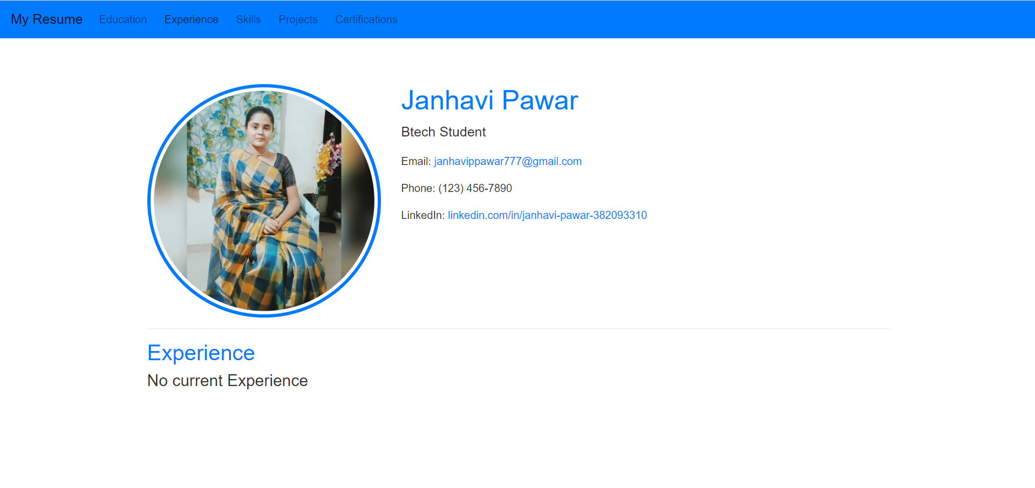

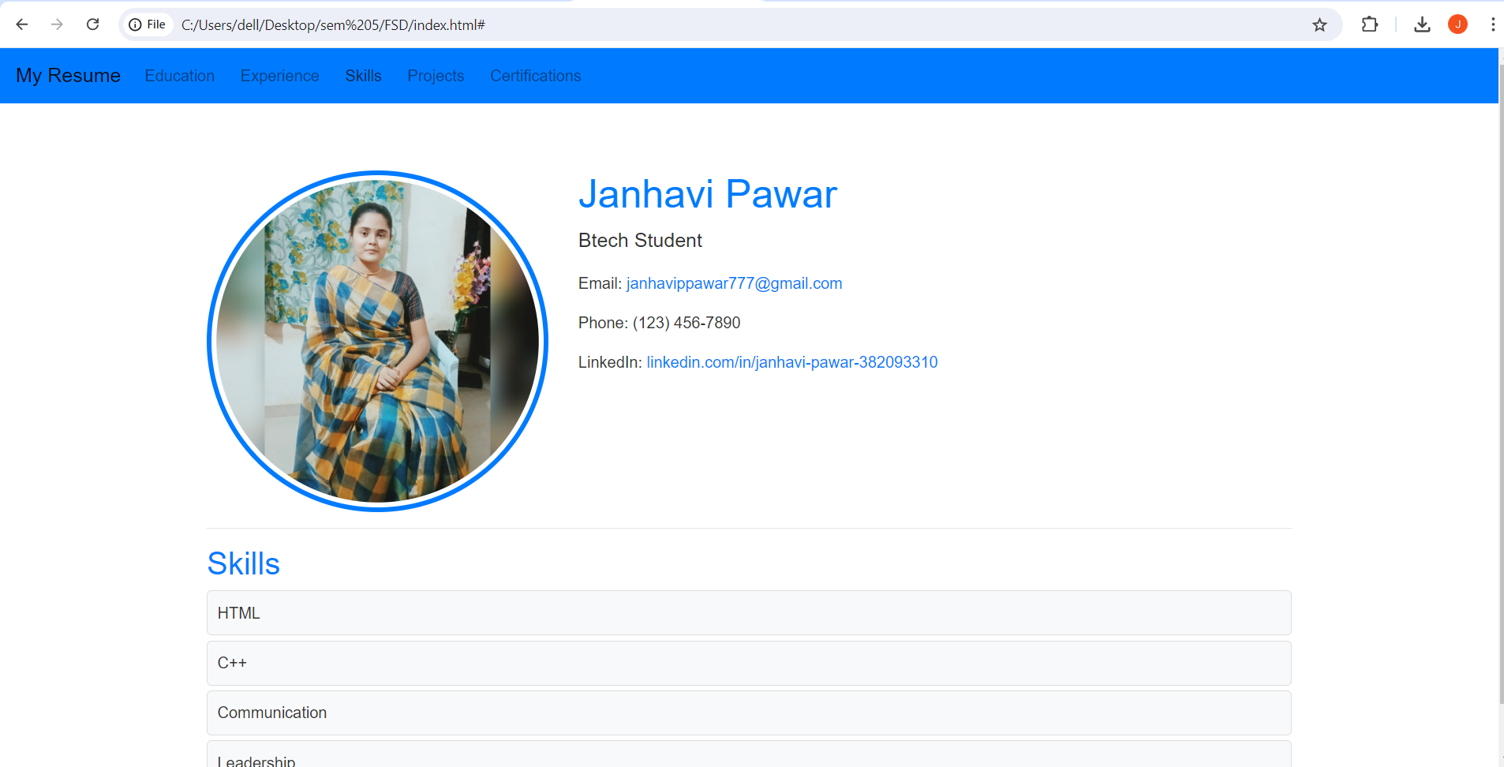

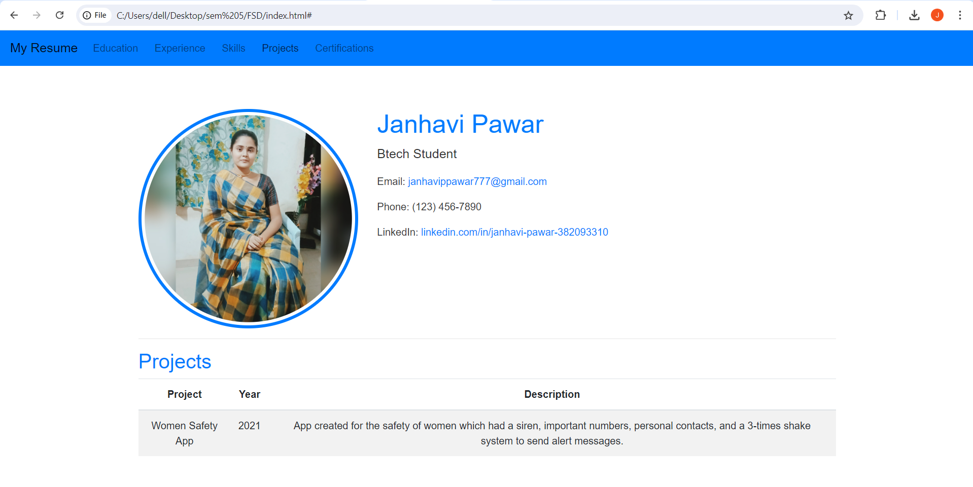

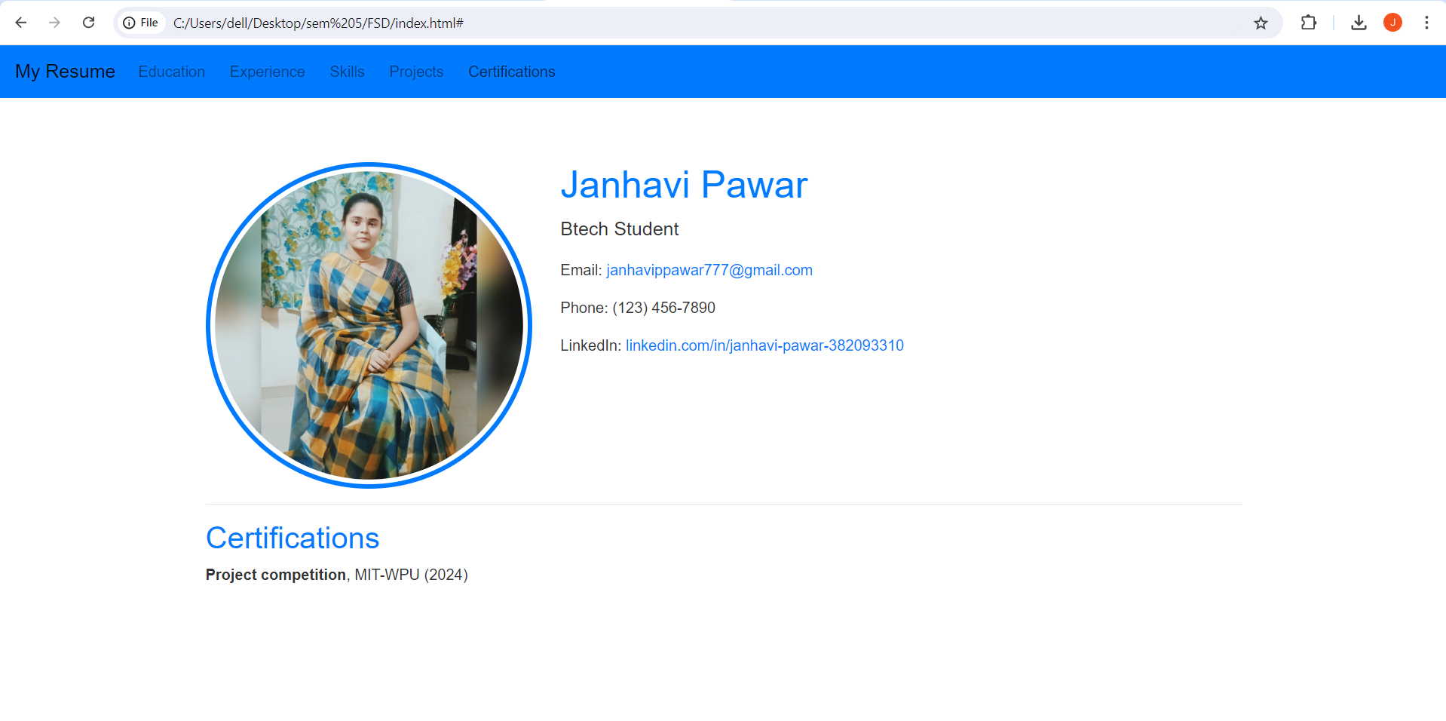

**Minimized View:**

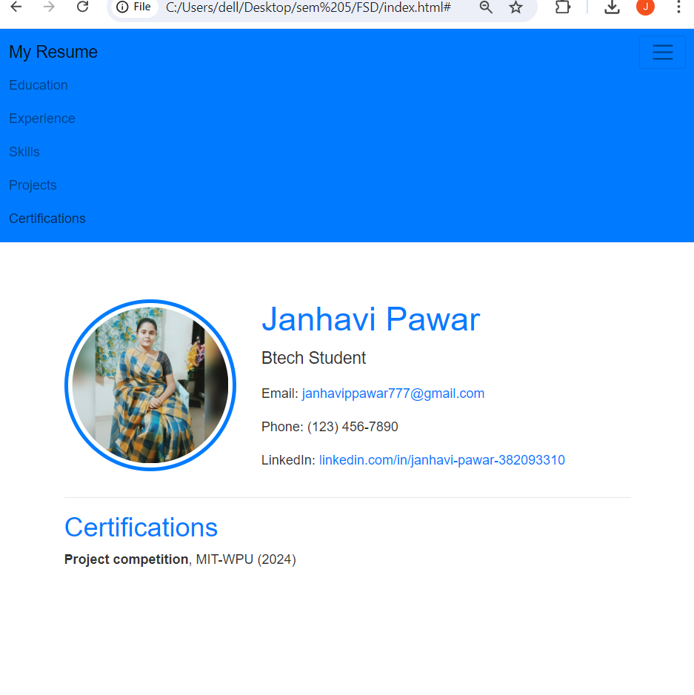

**Problem Statement:**

Design and develop a responsive web page (For example student registration, course enrollment, library management system, online shopping system etc.) using Bootstrap front end framework. Web pages should contain HTML5 elements (Use all possible formatting for example font, colour etc.).

Web page should include various

* images,
* links within the page,
* tables
* lists
* form elements
* paragraphs
* links to other pages for navigation,
* new tabs.

Use Cascaded Style Sheets (CSS) to style the web pages designed. Make use of

* Three types of styles (Inline, Internal and External)
* border,
* margins,
* padding,
* navigation,
* dropdown list
* tag selector
* class selector
* id selector
* exploring background image and position property etc.